# →Mixing Agile Approaches

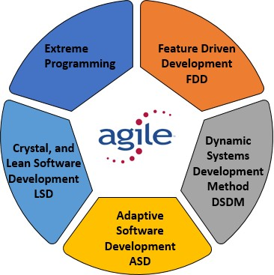Mixing agile approaches refers to the practice of combining different agile methodologies, principles, or practices to suit the specific needs and context of a project or organization. Agile approaches, such as Scrum, Kanban, Extreme Programming (XP), Lean, and others,

offer various frameworks and techniques for managing and delivering software development projects in an iterative and incremental manner.

When mixing agile approaches, organizations or teams may adopt and adapt different elements from multiple methodologies to create a customized approach that best fits their requirements. This approach recognizes that each project or organization has unique characteristics and may benefit from incorporating various agile practices.

## Example:-

For example, a team might combine the Scrum framework for project management with elements of XP for technical practices like test-driven development or pair programming. They could also integrate Kanban principles to visualize and optimize their workflow. The objective is to create a flexible and tailored approach that maximizes productivity, collaboration, and value delivery.

By mixing agile approaches, organizations can take advantage of the strengths of different methodologies while avoiding their potential limitations. It allows teams to leverage the best practices from each approach and create a hybrid or blended agile methodology that suits their specific needs, culture, and project requirements.

# →Process Model Involved in Mixing Agile Approaches:-

Agile approaches typically do not adhere to traditional process models like the Waterfall model. Instead, they emphasize iterative and incremental development, collaboration, and continuous improvement. However, there are several popular frameworks or methodologies within the agile domain that provide structured approaches to managing projects.

## Scrum:-

Scrum is one of the most widely used agile frameworks.

It includes specific roles (such as Scrum Master and Product Owner), events (like Sprint Planning, Daily Stand-ups, Sprint Review, and Retrospective), and artifacts (such as Product Backlog, Sprint Backlog, and Increment). Scrum emphasizes short iterations called sprints and focuses on delivering small, valuable increments of working software.

## Kanban:-

Kanban is a visual management system that emphasizes workflow visualization, limiting work in progress, and continuous delivery. It involves the use of a Kanban board to represent work items, their statuses, and the flow of work through different stages. Kanban provides transparency, enables teams to optimize their workflow, and promotes a steady and sustainable pace of work.

## Extreme Programming (XP):-

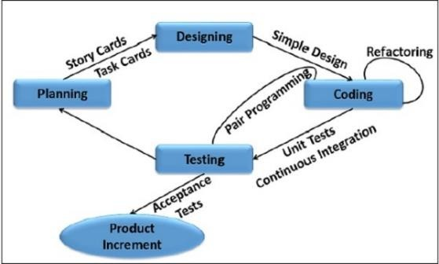Extreme Programming is an agile methodology that focuses on delivering high-quality software through practices like test-driven development, pair programming, continuous integration, and frequent customer feedback. It emphasizes close collaboration, simplicity, and fast feedback loops.

Lean Software Development: Lean Software Development draws inspiration from lean manufacturing principles. It emphasizes the elimination of waste, continuous improvement, and delivering value to customers. Lean practices include value stream mapping, optimizing flow, and reducing cycle time.

## Dynamic Systems Development Method (DSDM):-

DSDM is an agile framework that provides a comprehensive approach to software development projects. It emphasizes active user involvement, iterative development, and the timely delivery of business value. DSDM includes specific phases and activities to guide the development process.

These process models/frameworks offer guidelines, practices, and principles to manage agile projects effectively. However, it's important to note that agile approaches prioritize flexibility and adaptation, allowing teams to tailor and mix practices from different methodologies to suit their specific project and organizational needs.

# →Need for Mixing Agile Methodologies:-

## Project Complexity:-

Agile methodologies offer effective solutions for managing projects with moderate complexity.

However, some projects may have unique or high levels of complexity that require additional practices or frameworks. By mixing agile approaches, organizations can incorporate elements from different methodologies to address specific project complexities and challenges.

## Organizational Culture:-

Each organization has its own culture, values, and ways of working. Trying to impose a single agile methodology on all projects may not align with the existing culture or be suitable for every team.

Mixing agile approaches allows organizations to adapt and customize agile practices to align with their unique culture, values, and ways of working. It enables smoother adoption and acceptance of agile principles throughout the organization.

## Continuous Improvement:-

Agile is based on the principles of inspection and adaptation. Mixing agile approaches allows organizations to continuously learn, experiment, and improve their practices. By incorporating different elements from various methodologies, teams can experiment with different approaches and adopt the ones that yield the best results for their specific context.

## Hybrid Environments:-

Many organizations operate in hybrid environments where both traditional and agile approaches coexist. Mixing agile approaches allows teams to bridge the gap between these two worlds, enabling seamless collaboration and integration across different project management approaches.

By mixing agile approaches, organizations can customize their project management practices to meet the specific needs of their projects, teams, and organizational context. It provides the flexibility to adapt and optimize agile principles, practices, and frameworks, resulting in improved project outcomes, higher team satisfaction, and better alignment with business objectives.

# →Advantages of Mixing Agile Approaches

## Flexibility:-

Mixing agile approaches provides flexibility to tailor project management practices to specific project requirements, team dynamics, and organizational context. It allows teams to choose the most effective elements from different methodologies and adapt them accordingly.

Customization: Organizations can create a customized agile approach by combining practices that best suit their needs. This allows for a more tailored and optimized project management approach, increasing the chances of project success.

## Adaptability:-

Mixing agile approaches enables teams to adapt to changing circumstances, evolving requirements, and new challenges. By integrating multiple methodologies, teams can respond effectively to different project contexts and adjust their practices as needed.

## Enhanced Collaboration:-

Different agile approaches promote collaboration and communication within teams. By mixing methodologies, teams can combine practices that encourage collaboration and teamwork, fostering better communication and knowledge sharing among team members.

## Scalability:-

Mixing agile approaches allows organizations to scale their agile practices to larger projects or multiple teams. By incorporating scaling frameworks, organizations can effectively manage and coordinate efforts across larger initiatives.

# →Disadvantages of Mixing Agile Approaches

## Complexity:-

Mixing agile approaches can introduce additional complexity to project management. Combining different methodologies requires careful planning, coordination, and training. Managing multiple practices simultaneously may increase the complexity of project execution and require additional effort.

## Inconsistent Practices:-

Mixing agile approaches can result in inconsistent practices across teams or projects within an organization. This may make it challenging to establish standardized processes or share resources between teams. It could also create confusion if team members are not familiar with the specific practices being used. Integration Challenges: Integrating different agile approaches may require extra effort to ensure compatibility and smooth integration between practices. Some methodologies may have conflicting principles or practices that need to be resolved, which can be time-consuming and resource-intensive.

## Skill and Knowledge Requirements:-

Mixing agile approaches may require teams to have a broader range of skills and knowledge.

Team members need to be trained in different methodologies and familiar with the specific practices being used. This can increase the learning curve and resource requirements for team development.

## Increased Management Effort:-

Managing a mixed agile approach may require additional effort from project managers or agile coaches. They need to understand and coordinate various practices, ensure alignment between teams, and provide guidance on the appropriate application of different methodologies.

It's important to note that the pros and cons of mixing agile approaches can vary depending on the specific context and implementation. It's crucial for organizations to carefully evaluate the benefits and challenges before adopting a mixed agile approach and ensure proper planning, training, and support to maximize the advantages while mitigating potential drawbacks.